**ASSESSMENT OF RESERVOIR PROCESSES INDUCED BY GEOTHERMAL UTILIZATION AT REYKJANES, SW-ICELAND, INFERRED FROM INTERFEROMETRIC ANALYSIS OF SATELLITE IMAGES AND GNSS GEODESY 2005-2019**

Mylene Receveur, Freysteinn Sigmundsson, Michelle Parks, Vincent Drouin, Halldor Geirsson, Sigrun Hreinsdottir, Omar Sigurdsson

Nordic Volcanological Center, Institute of Earth Sciences, University of Iceland, Reykjavik, Iceland

myr2@hi.is

**Keywords:** High-temperature geothermal system, Radar interferometry, Time-series analysis; Inverse theory; Ground deformation modeling;

# Abstract

We study local deformation induced by geothermal utilization of the high-temperature Reykjanes system, SW-Iceland, since 2006 when a new 100 MWe power plant began operation. Using interferometric analyses of synthetic aperture radar (InSAR) of images acquired by the Sentinel-1 satellites, we provide an update of the time series of surface displacement above the geothermal reservoir for the 2015-2019 time period.

Results from previous studies showed that the highest rates were observed for the 2005-2008 study period, where the main deformation area was aligned along the Reykjanes fissure swarm in the vicinity of the power plant. From 2009, the deformation zone narrowed to a 2-km wide circular subsidence bowl centered on the well field accompanied by a decrease in the maximum subsidence rate. Time-series of range change in the satellite line-of-sight (LOS) for the 2015-2019 period confirm the continuous deflation in the area of maximum geothermal utilization, however at an increased rate during the 2018-2019 time interval. A total subsidence of about 330 mm together with horizontal contraction towards the centre of deflation of up to about 220 mm is calculated for the 2006-2019 period.

The average ascending and descending LOS velocities are used to invert for the characteristics of the deformation source for the 2015-2019 and 2018-2019 time periods, modeling the reservoir as a body of simple geometry within an elastic half space. Results for both period indicate a best-fitting source at ~1.4 km contracting at a rate of −0.9×105 m3yr−1. The decrease in the rate of volume change together with the migration of the best-fitting source toward shallower depth between the 2005–2008 and 2009-2019 periods was attributed to a change in the deformation processes within the reservoir. While deformation in the 2005-2008 period was related to the compaction of deep rocks as a result of a 3 Mpa pressure drop in the initial years of geothermal production, the continuous subsidence since 2009 was attributed to a combination of both poro- and thermo-elastic compaction within or near a steam cap, formed in the topmost part of the reservoir in response to this pressure drop.

Pressure measurements since the end of 2017 indicates a new pressure decline at 1.6 km depth, that correlates well with the increase in subsidence and contraction rates observed in the center of the deformation field since 2018. However, we suggest that more time is necessary for the effects of this pressure drop to reach the surface and to be able to determinate more precisely the characteristics of the deformation source from 2018, through inverse modeling of geodetic data.

# 1. Introduction

Since the 1990, Interferometric Synthetic Aperture Radar (InSAR) satellite imaging methods have been increasingly used to study ground deformation induced by geothermal utilization. The combined used of GPS-Geodesy and InSAR has proven to be an efficient tool to monitor long-term changes within geothermal reservoirs. We here undertake an extended interferometric analysis of Sentinel-1 image acquired between 2017 and 2019 at the Reykjanes geothermal system, SW-Iceland, and integrate the result into the long-term deformation history provided by studies from Parks et al. (2018) and Receveur et al. (2019) to understand changes in the reservoir resulting from geothermal utilization in this area.

The high-temperature Reykjanes geothermal system is located where the Mid-Atlantic Ridge emerges on the southwestern tip of the Reykjanes Peninsula in Iceland. The geological structure consists of a highly fractured superimposition of volcano-sedimentary strata and subaerial Pleistocene lava flows. The upper part of the series is dominated by phreato-magmatic tuffs and breccias intersected by thin layer of fossiliferous marine sediments, mainly found between 400 and 800 m depth. Below 1100 m depth, the sequence is dominated by crystalline pillow basalts and breccias formed in deep-water environments. An increasing density of dyke intrusions are encountered in wells below 1.5 km depth, and dominate the sequence from 2.8 km depth. The geothermal reservoir is bounded by two main faults channeling recharge from the SW and forming a NE/ENE graben structure. The highest temperatures at 1 km depth were measured in well RN-10, situated in the central part of this graben (Franzson et al. 2002). On surface, an area of intense hydrothermal activity of about 1.5-2 km² has been used to delineate the central part of the reservoir, where the permeability and temperatures are the highest (Fridriksson et al. 2010). Assuming a thickness of 1500 m, the total volume of the productive reservoir was estimated to be approximately 3 km3. Some productive layers have been identified within porous formations at 800–1200 m depth, below the highly altered reservoir cap rock located in the 400-900 m depth range (Franzson et al. 2002; Friðleifsson et al. 2014). However, most of the feed zones are fracture-related and irregularly distributed within the reservoir, the largest ones being associated with sub-vertical fractures along or near dykes between 1.9 and 2.3 km depth (Franzson et al. 2002).



**Figure 1. Geological maps. (a) Reykjanes Peninsula (Hjartarson & Saemundsson 2014), showing central volcanoes (red dashed lines) and the contours of the fissure swarms (orange dashed lines) after Johannesson & Saemundsson (1998), fault and fissures (black lines) and the direction of plate spreading (blue arrows) after Clifton & Schlische (2003). Inset shows the location of the map (black square) and the coverage of the Sentinel-1 ascending (T16) and descending (T155) tracks in Iceland. (b) Reykjanes geothermal system (after Saemundsson et al. 2010) showing the youngest lava flows and crater rows (red features) west of the area of high surface alteration (after Friðleifsson et al. 2018). (c) Map showing the location of drillholes (red and yellow circled crosses) and the ground surface traces of directionally drilled wells (black lines). Most of the wells are situated within the main upflow zone (red contour line) identified from resistivity surveys by Karlsdottir & Vilhjalmsson (2014), centred on the Gunnuhver thermal area, where the surface manifestation of hydrothermal activity is the highest. See legend for explanations of all symbols.**

Geothermal production at Reykjanes was initiated in 1976 but the highest extraction rates were reached in 2006 when a new 100 MWe powerplant was commissioned. About 800 kg/s of fluid were extracted during the three first years of production, resulting between May 2006 and May 2009 in a 3 MPa pressure drop at ~1600 m depth that increased boiling conditions in the reservoir. While the main feed zones at 1.9-2.3 km depth are still liquid dominated, those situated between 800 and 1200 m depth began to supply the wells with saturated steam in 2008 (Sigurdsson 2010). That year, two relatively shallow wells, RN-27 and RN-28, were drilled in the central part of the system down to 1225 m and 960 m depth, respectively, to produce directly from this steam cap in the uppermost part of the reservoir (Fridriksson et al. 2010). In 2018, 21.3 Mt of geothermal fluid were extracted by 15 deep production wells and the two shallow wells (Þorvaldsson & Arnaldsson 2017). Reinjection was initiated in 2009 at a rate of 15 kg/s at about 2.5 km depth to counterbalance pressure in the reservoir, and was performed since then within 5 wells at irregular rates, averaging to 75 kg/s during the 2009-2018 time period, with a maximum of 146 kg/s in 2016.

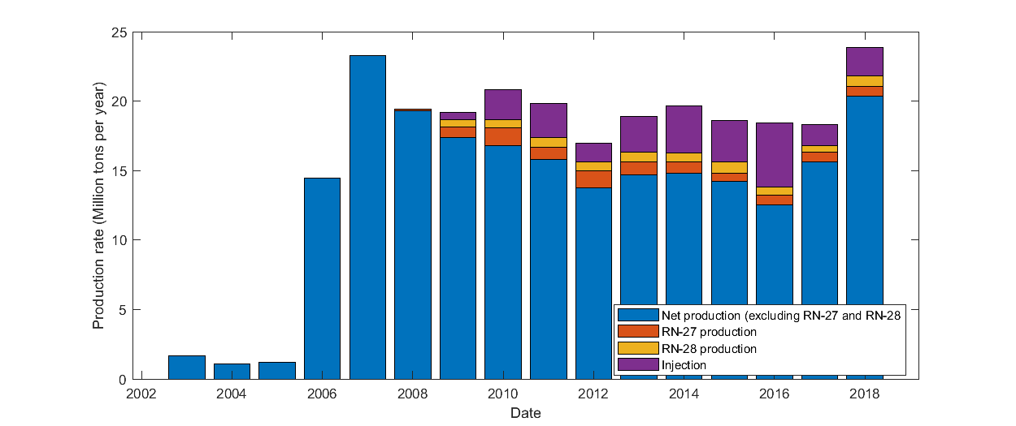

**Figure 2: Net production rate (difference between extraction and injection rates) for all wells except shallow dry steam wells RN-27 and RN-29, extraction rates for RN-27 and RN-28 and injection rates for the period 2003-2018.**

Monitoring of ground deformation started in Reykjanes before the commissioning of the new powerplant in 2006. Previous studies of deformation in this region include those undertaken by Keiding et al. (2010), Gunnarsson (2012), Michalczewska et al. (2014) and Parks et al. (2018). Parks et al. (2018) undertook interferometric analysis of Envisat and TerraSAR-X data acquired between 2003 and 2016 to determine rates of displacement and provide constraints on the cumulative deformation field caused by utilization. Timeseries of displacement were extended in Receveur et al. (2018) with the use of Sentinel-1 satellite data spanning the 2015-2017 period, together with an analysis of the physical processes responsible for the observed deformation at Reykjanes.

We here provide an update of the time series of deformation obtained from the InSAR analysis using Sentinel-1 images from March 2017 to May 2019, and evaluate deformation processes. We perform a probabilistic inversion to determine the optimal parameters for the deformation source during the periods 2015-2019 and 2017-2019 and compare the results with the production rates, pressure and temperature changes at depth, to infer the physical processing responsible for the deformation.

# 2. METHODS

## 2.1 InSAR analysis

Synthetic Aperture Radar (SAR) images of Reykjanes from the period 2003-2019 have been utilized to study ground motion over the geothermal reservoir. InSAR analysis determines the phase shift between SAR images acquired from approximately the same location overhead but at different times (e.g. Liu et al. 2017). Interferograms are formed by comparing an initial “master” SAR image with a second “slave” image. As the satellite is “side-looking”, the relative displacement value of each pixel *d*LOS is recorded as phase change, representing range change in the LOS direction towards the satellite (Massonnet & Feigl 1998) proportional to the radar wavelength. In the absence of errors, it corresponds to the projection of the three-dimensional displacement field đ=[dE,,dN,dUp ] onto the unit vector ū=[uE,uN,uUp] pointing from the ground to the satellite:

dLOS= - đ • ū (1)

Ascending and descending interferograms covering the period 2003-2017 (Parks et al., 2018; Receveur et al., 2019) were formed from sets of images acquired over the study area by three different satellites. Data from the ENVISAT satellite covering the period 2003-2009 and from the TSX satellite covering the period 2009-2016 were processed using the DORIS software (Kampes and Usai, 1999). The STaMPS (Stanford Method for Persistent Scatterers) software (Hooper et al., 2007; Hooper et al., 2012) was used to generate independent time-series of displacement in the satellite's LOS for each period covered by the InSAR data and map the temporal evolution of deformation in the vicinity of the Reykjanes power (Parks et al., 2018). For the period 2015-2017, Receveur et al. (2019) used data from the two C-band Sentinel-1A and 1B satellites launched by the European Space Agency in 2014 and 2016, respectively. Table below summarizes the characteristics of each satellite and study period (Table XXX).

|  |  |  |  |  |  |  |  |
| --- | --- | --- | --- | --- | --- | --- | --- |
| Satellite | Wavelength | Total image | Period covered | Orbit | Track | Heading | LOS vector |
| ENVISAT | C-band | 7 | 09/2005-08/2008 | Ascending | 173 | 339 | [-0,319; -0,123; 0,940] |
| ENVISAT | C-band | 24 | 2003-2009 | Descending | 138 | 201 | [0,395; -0,152; 0,906] |
| TSX | X-band | 59 | 09/2009-2016 | Ascending | 26 s013 | 349 | [-0,670; -0,130; 0,731] |
| TSX | X-band | 31 | 2009-2016 | Descending | 110 s008 | 193 | [0,531; -0,123; 0,839] |
| SENTINEL-1 | C-band | 40 | 08/2015-10/2017 | Ascending | 16 | -13 | [0,545; -0,123; 0,830] |
| SENTINEL-1 | C-band | 44 | 04/2015-10/2017 | Descending | 155 | -169 | [-0,605; -0,123; 0,787] |

**Table 1. Summary of the characteristics of the satellites and images used for studies of ground deformation at Reykjanes in previous studies (Parks et al., 2018; Receveur et al., 2019)**

In this study, we analyzed a total of 81 and 77 images from the Sentinel-1 ascending track T16 and descending track T155, respectively, covering the period January 2018 to May 2019. Among them, only 36 and 27 images covering the period March 2018 to May 2019 were selected for the final time series analysis, after removal of those significantly polluted by atmospheric noise as judged by visual inspection. The whole set of 2015-2019 Sentinel-1 images, totaling 76 images for T16 and 71 images for T155, were processed using the method described in Receveur et al. (2019) and used to generate an extended time series of deformation covering the October 2015 - May 2019 period.

Interferograms were formed using the InSAR Scientific Computing Environment Software (ISCE). The selected SAR images were co-registered to a single master image in each track, acquired on 20 August 2016 in T16 and 30 August 2016 in T155. For each track, average LOS velocity maps were generated over the Reykjanes area. Displacement rates were determined for pixels having a coherence higher than 0.3 (as estimated by the ISCE software) in each interferogram, using linear regression of the LOS displacement values within the whole time series of interferograms. In addition, we created time series of LOS displacements for the average phase value of a set of pixels situated in the area of highest deformation of the ascending and descending velocity maps. This approach was applied in order to reduce potential effects from individual pixels with significant noise.

In addition, the vertical (“near-vertical”) nV and the east (“near-east”) nE component of the 2015-2019 deformation field have been derived using a linear combination of the LOS velocities measured in the ascending and descending tracks (see e.g. Mickalczewska et al., 2014, Keiding et al. 2010, Parks et al., 2018), as described in Receveur et al. (2019). Those were used to estimate the cumulative displacement throughout the study period.

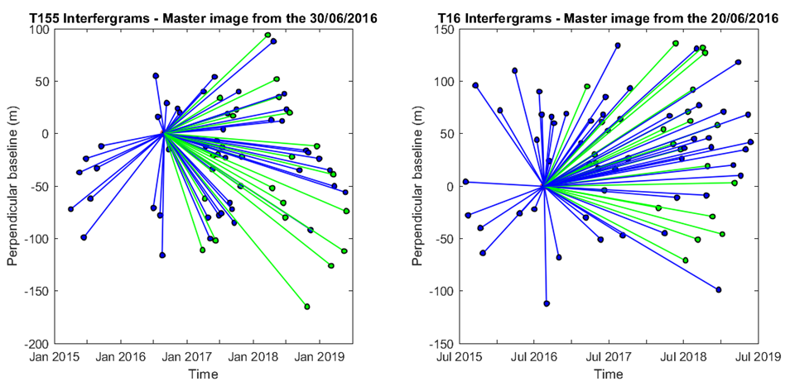

**Figure 3. Star graphs showing the temporal and perpendicular baselines (distance between the locations of the satellite at the two acquisition times, in the direction perpendicular to the satellite viewing direction) of the 70 interferograms of the T155 time-series (left-hand panel) and the 75 interferograms of the T16 time-series (right-hand panel) used in the time-series analysis and for the construction of the average velocity maps. Each dot corresponds to a single image from Sentinel-1A (in blue) and Sentinel-1B (in green) and each line represents an interferogram (modified from Receveur et al., 2019).**

## 2.2 Geodetic modeling

We inverted the average LOS displacement rates obtained from the time series analyses to estimate the parameters of a contracting source at depth that best replicates the 2015-2019 observations. A set of models representing deformation sources embedded within a homogeneous, isotropic and uniform elastic half-space are considered. For the periods 2005-2008 and 2009-2016, a point pressure source (Mogi 1958) and an ellipsoid source (Yang et al., 1988) representing the geothermal reservoir were tested using a Poisson’s ratio v=0.27 (Parks et al. 2018). For the period 2015-2019, the Mogi source as well as a spherical source (McTigue, 1987), a planar horizontal square sill with uniform closing (Okada 1985) and a horizontal penny shaped crack (Fialko et al. 2001) were tested with a Poisson’s ratio v=0.25. Those models are assumed to correspond to a part of (i.e. the steam zone) or the total volume of the geothermal reservoir causing the observed deformation. Here, the inversions were performed based on a Bayesian optimization approach, using both the Geodetic Bayesian Inversion Software (GBIS) developed at the University of Leeds (Bagnardi and Hooper., 2017, 2018) and the modelling approach from Drouin et al. (2017), as explained in Receveur et al. (2019).

# 3. RESULTS

## 3.1 Background from previous studies

InSAR analysis from 2005 to 2016 (Parks et al. 2018) showed that in the initial years of production (2005-2008 period), the LOS deformation signal at Reykjanes together with the near-vertical and near-east displacements are characterized by an elongated elliptical shape trending in the NE-SW direction. During the 2009-2016 period, velocity maps reveals that the highest LOS and near-vertical displacements are located in the center of a sub-circular deformation bowl centered on the well field. The near-east displacement is also more focused and in shape and is characterized by a contraction towards the center of the zone of highest deformation. Results for the 2015-2017 period covered by the Sentinel-1 data (Receveur et al., 2019) indicated similar deformation pattern compared to the 2009-2016 one. They also confirmed the continuous decrease in the average rate of maximum subsidence measured in the most deforming area relative to the InSAR reference area situated to the east of the geothermal field. Using the near-vertical and near-east velocities derived for each time period (Table XXX), a maximum cumulative subsidence and contraction of -0.289 and 0.148 m, respectively, were inferred for the period June 2005 – October 2017.

|  |  |  |  |  |  |
| --- | --- | --- | --- | --- | --- |
| **Satellite** | **Track** | **Period** | **LOS rate (mm/yr)** | **Volume change** | **Near-vertical / Near east displacement** |
| ENVISAT | A | 18/06/2005-16/08/2008 | -33 | -2.3 × 106 m3  -7.3 × 105 m3/yr | -0.08 m  -0.07 m and + 0.07 m |
| D | 16/06/2005-14/08/2008 | -28 |
| TSX | A | 29/09/2009-11/08/2016 | -24 | -1 × 106  -1.5 × 105 m3/yr | -0.19 m  -0.12 m and +0.06 m |
| D | 24/09/2009-17/08/2016 | -21 |
| TOTAL 1 (Parks et al. 2018) | | | | | -0.26 m  0.14 m |
| Sentinel-1 | A | 02/08/2015-14/10/2017 | -16 | -0.9 × 106 m3/yr | -25 mm/yr  -10 mm/yr and +5 mm/yr |
| D | 02/04/2015-30/10/2017 | -20 |
| TOTAL 2 (Receveur et al., 2019) | | | | -3.8 × 106 m3 | -0.289 m  0.148 m |

**Table 2. Summary of results from previous studies, including the LOS displacement rates, near-east and near-vertical velocities in areas of maximum deformation and volume changes of the best fitting deformation sources for each study period.**

Inverse models for the 2005-2008 and 2009-2016 time period were performed using the cumulative LOS displacements obtained for each time period (Parks et al., 2018). The optimal source for the period covering the ENVISAT observations (2005-2008) corresponds to a near-horizontal ellipsoidal source at about 2.2 km depth, displaying a volume change of −2.3 × 106 m3. In the period spanning the TSX observations (2009-2016), results indicated a volume change of −1.0 × 106 m3 for a best fitting point pressure source situated at about 1.2 km depth. This decrease in the rate of volume change was is confirmed by results obtained from the inversion of the average LOS displacement rates for the period 2015-2017, covered by the Sentinel-1 data. The best fit was there obtained for a penny shaped crack and a contracting horizontal sill located at about 1-1.4 km depth and contracting by an amount of about 0.9 × 105 m3/yr. For all time periods, the locations and the dimensions of the modelling sources suggest that the deformation originates from the area of maximum production, slightly to the southeast of the hottest part of the system (around RN-10) and north of Gunnuhver fumarole (Fig. XXX).

## 3.2 InSAR results 2015-2019

LOS velocity maps for the whole 2015-2019 period reveal a relatively sub-circular deformation pattern centered on the geothermal field (Fig. XXX), as observed during the 2015-2017 time period (Receveur et al., 2019). Time-series analyses for the 2015-2019 period also reveal a relatively steady and linear trend over the study period, with an average maximum LOS rate of -20 mm/yr for Sentinel-1 T16 and -23 mm/yr for T155 in the assumed zones of maximum deformation, relative to the InSAR reference point. This reference point (-22.564°E; 63.814°N) is situated near the STAD GPS station where a natural subsidence at a rate of about 6 mm/yr was measured before production began in 2006 (Hreinsdottir et al. 2001). As subsidence of this station has continued at a similar rate after the production began, using this point as a reference allows us reducing the contribution of other natural deformation signals compared to those induced by geothermal utilization (Parks et al. 2018).

We also performed independent linear regressions of the LOS displacements from interferograms comprised in the 2015-2017 and 2018-2019 periods to identify potential disparities between the two periods. For both ascending track 16 and descending track 155, we observe a slight increase in the LOS displacement rates, from -17 to -25 mm/yr for T16 and from -24 to -27 mm/yr for T155, for the 2015-2017 and 2017-2019 time periods, respectively (Fig. XXX).

Results from the decomposition of the signal in near-vertical and near-east displacements finally shows similar patterns to the ones obtained for both the 2009-2016 and 2015-2017 periods (Parks et al., 2018; Receveur et al., 2019). The maximum near-vertical displacement rate, located in the central part of the subsidence bowl, is about -26 mm/yr relative to the InSAR reference area. The near-east displacement field is characterized by a contraction towards the center of this zone of highest deformation, with an eastward displacement of about 7 mm/yr of the western part of the field and a westward motion of about -11 mm/yr of the easternmost part. Details for the periods 2015-2017 and 2018-2019 are summarized in Table XXX. As shown in Fig. XXX, the highest rates of displacement in the area of maximum change were observed during the first 2–3 years of production (Parks et al., 2018), followed by an exponential decrease between 2008 and 2017, as described in Receveur et al. (2019). Based on the average 2015-2019 near-vertical and near-east velocities of -26 and 9 mm/yr, and on the values of cumulative subsidence and contraction in August 2016 estimated by Parks et al. (2018), we inferred a cumulative subsidence and contraction of -0.33 m and 0.17 m for the whole period June 2005-May 2019.

Results for the 2018-2019 period are more uncertain than those for the 2015-2017 period, due to the lower coherence of the interferograms during this period (higher perpendicular baseline, with a maximum of -165 m for the 2016 August 30–2018 October 25 interferogram (T155)). However, the analysis of Sentinel-1 data in the 2018-2019 period data suggests a slight increase in the contraction and subsidence rates compared to the 2015-2017 period, in accordance with the increased LOS displacement rates observed in 2018-2019 (Fig. XXX). We therefore perform inversions of the Sentinel-1 InSAR data for the periods 2015-2019 and 2018-2019 to determine the location and the volume change of the best-fitting deforming sources at depth during those time periods.

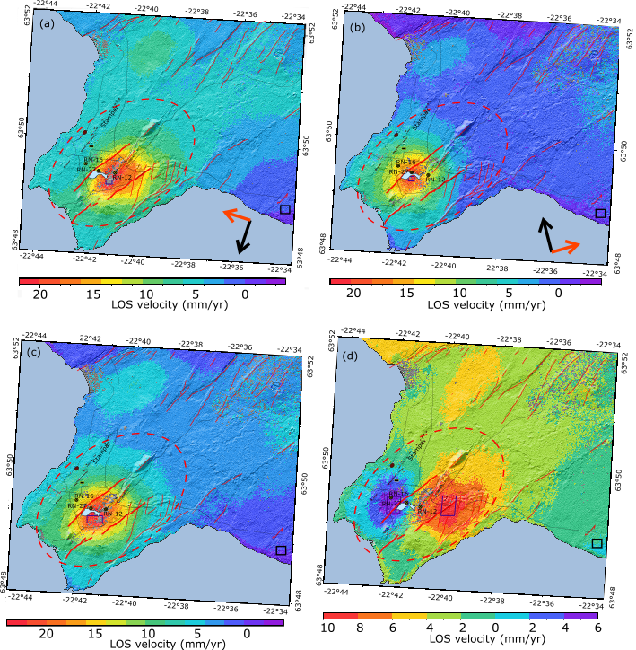

**Figure 4. (a) LOS velocities for ascending Track 155 and (b) LOS velocities for descending Track 16. (c) Estimated near-vertical velocity component and (d) near-east horizontal velocities; in mm/yr, for the period 2015-2019. The grey colour indicates the areas with low coherence (<0.3) in all interferograms in the timeseries. The black square corresponds to the reference area and the dark blue correspond to the sampling areas for the estimation of the average displacement rates. These sampling areas contain 218, 160, 637 and 1769/2201 pixels with coherence >0.3 in T16, T155, in the near-vertical and near-east velocity maps (western and eastern areas), respectively. The red dashed circle indicates the location of the Reykjanes central volcano, the thin red lines represent the faults and fractures of the fissure swarm (Clifton & Schlische 2003) and the red bold lines correspond to the main Litla–Vatnsfell and Skalafell faults.**

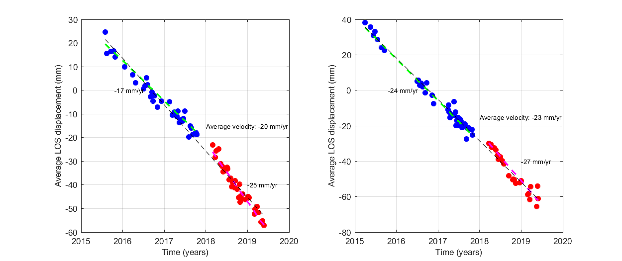

**Figure 5. Time-series analysis of the average displacement of a set of points situated in the middle of the most deforming area, for pixels having a coherence> 0.3 in the selected interferograms. Due to the lack of pixels in the area of maximum deformations for the period 2018-2019, the areas of selection for the timeseries have been shifted and expanded (see dark blue squares in Fig. XXX), which explains the differences with the average maximum 2015-2017 velocities calculated in Receveur et al. (2018). (a) Average LOS change of pixels within the area (−22.693◦E; −22.689◦E; 63.821◦N; 63.823◦N) for T16 relative to a master image acquired on the 20 August 2016. (b) Average LOS change of pixels within the area (−22.687◦E; −22.683◦E; 63.820◦N; 63.821◦N) for T155 relative to a master image acquired on the 30 August 2016.**

|  |  |  |  |  |  |
| --- | --- | --- | --- | --- | --- |
| Satellite | Track | Period | LOS Rate (mm/yr) | Volume change (m3/yr) | Near-vertical/near-east velocities (mm/yr) |
| Sentinel-1 2015-2019 | A | 02/08/2015-25/05/2019 | -20 | (0.7-0.9)×105  1200 m depth | -26 mm/yr  -11 and + 7 mm/yr |
| D | 02/04/2015-29/05/2019 | -23 |
| Sentinel-1 update  2015-2017 | A | 02/08/2015-14/10/2017 | -17 |  | -27 mm/yr  -12 and +6 mm/yr |
| D | 02/04/2015-30/10/2017 | -24 |
| Sentinel-1 2018-2019 | A | 01/03/2018-25/05/2019 | -25 |  | -41 (-26 for pixels coh >0.3)  -16 and +15 mm/yr  (-13 and +11 if coh >0.3) |
| D | 23/03/2018-29/05/2019 | -27 |

**Table 3. Summary of the LOS displacement rates, near-vertical and near-east displacement rates. Sampling areas area for the maximum average rates are (-22.693°E; -22.683°E; 63.820°N; 63.822°N) in the near-vertical velocity map, and (22.704°E; -22.695°E; 63.821°N; 63.826°N) for the eastward displacement and (-22.668°N; -22.659°N; 63.821°N; 63.827°N) for the westward displacement area in the near-east velocity map, as shown in Fig. XXX.**

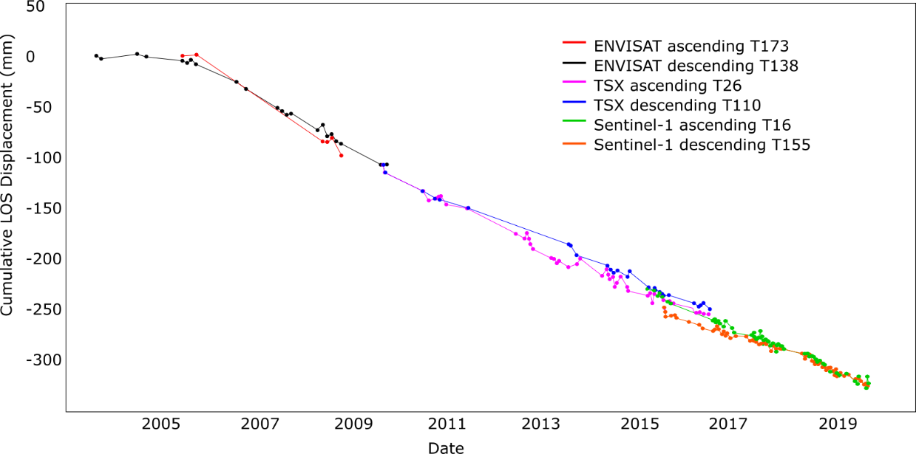

**Figure 6. Time series of line-of-sight (LOS) displacement for the whole period 2003-2019. The displacement time series displays the difference between two reference areas.**

## 3.3 Models

# References <heading 1 style>

Verma, A., and Pruess, K.: Enhancement of Steam Phase Relative Permeability Due to Phase Transformation Effects in Porous Media, *Proceedings,* 11th Workshop on Geothermal Reservoir Engineering, Stanford University, Stanford, CA (1986). <Reference Style>

Wang, C.T., and Horne, R.N.: Boiling Flow in a Horizontal Fracture, *Geothermics*, **29**, (1999), 759-772. <Reference Style>